Ben Sherman, Principal  Seung Oh, Assistant Principal  Mala Panday, Assistant Principal | 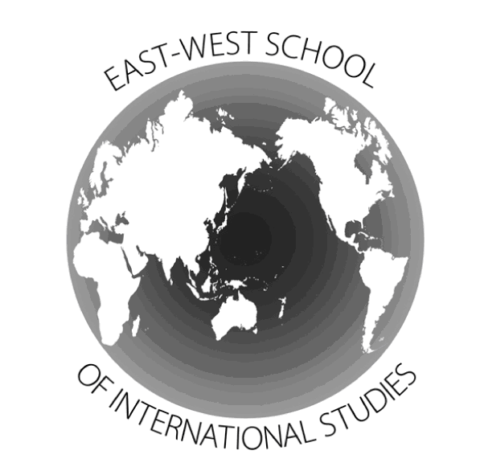 | 46-21 Colden Street Flushing, NY 11355  Phone: (718) 353-0009  Fax: (718) 353-3772  www.ewsis.org

Summer 2011
Dear East-West School of International Studies New Student:

Welcome to The East-West School of International Studies, home of Honor, Excellence, Curiosity and Celebration!

You are invited to attend our annual Summer Bridge orientation for sixth and ninth graders on Thursday, September 1, 2011. You will begin in room 418 at 9:00 a.m. Members of our Student Government and other students who will be earning community service credits, will be available to assist you with answering questions and tours.

Summer Bridge will include an introduction of administration, counselors, teachers, and other key personnel. You will also learn about school culture and procedures and engage in exciting activities with other new students.

Parents/guardians may join us at 11:00 a.m. for a question and answer session and then they will able to purchase uniforms and complete emergency contact information for the 2011-2012 school year. Summer Bridge will come to a close at 12:00 p.m.

As you continue to enjoy your summer, please log onto our website at www.ewsis.org to learn more about your school. We look forward to seeing you on September 1st at 9:00 a.m. If you have any questions about Summer Bridge, please feel free to contact Ms. Panday at (718) 353-0009.

Sincerely,

Ben Sherman Mala Panday
Principal Assistant Principal

